**A TECHNICAL REPORT ON STUDENT INDUSTRIAL WORK EXPERIENCE SCHEME(SIWES)**

**TRAINING PROGRAMME (2021) AT**

**BY**

**MOSES-GOMBO DIEPREYE T.**

**RUN/CMP/19/8459**

**IN PARTIAL FULFILMENT FOR THE AWARD OF BACHELOR OF SCIENCE(B.SC)**

**DEGREE IN COMPUTER SCIENCE**

**NOVEMBER 2021**

**DECLARATION**

I Moses-Gombo Diepreye T. declare that this project report is based on my own work carried out during the SIWES program under the supervision of Mr. Lukman Ademola (*It channels support Officer* – Globus bank).

I assert the statements made and conclusions drawn are an outcome of my research work. I further certify that:

1. The statements made and conclusions drawn are an outcome of my research work.
2. This work has not been submitted to any other Institution for any other degree/diploma/certificate in this university or any other University.
3. I have followed the guidelines provided by the university in writing the report.
4. Whenever I have used materials (data, theoretical analysis, and text) from other sources, I have given due credit to them in the text of the report and giving their details in the references.

**ACKNOWLEDGEMENTS**

I am grateful to Almighty God, the beginning and the end, my creator, and my everlasting father who preserved my life throughout the period of my SIWES program. May His name be glorified and worshipped forever. My profound gratitude goes to my parents and siblings for the tremendous contribution and support both morally and financially during my course of education. I pray the lord will continually bless you and guide you in His grace.

**ABSTRACT**

This report grants insight into the responsibilities/roles to be played by a support staff working to ensure payment channels like the ATM and POS are in check and always available to process transactions successfully. It also sheds light on some challenges that are most likely to occur in these payment channels, and their respective solutions; giving you a better understanding of what happens on the back end of every transaction, the other parties involved, and the processes that occur at every stage.

**TABLE OF CONTENT**

Title Page …………………………………………………………………………… I

Declaration …………………………………………………………………………. II

Letter of Certification………………………………………………………………. III

Acknowledgements ………...………………………………………………………. IV

Abstract ……………………..……………………………………………………… V

Table of contents ………...…………………………………………………………. VI

**CHAPTER ONE**

INTRODUCTION

1.0 INTRODUCTION TO THE STUDENT INDUSTRIAL WORK EXPERIENCE SCHEME (SIWES)

1.0.1 AIMS AND OBJECTIVES OF SIWES

1.1 THE ORGANISATION

1.1.1 HISTORY OF THE ORGANISATION

1.2 ORGANOGRAM AND RESPONSIBILITIES

1.3 ROLES/RESPONSIBILITIES AND ACTIVITIES

**CHAPTER TWO**

2.0 DETAILED ROLES/RESPONSIBILITIES AND ACTIVITIES

**CHAPTER THREE**

3.0 ATM AND POS

3.0.1 TERMS ASSOCIATED WITH POS PAYMENT CHANNEL

3.0.2 TERMS ASSOCIATED WITH ATM PAYMENT CHANNEL

3.1 PAYMENT PROCESS – THE BACKEND OF A TRANSACTION

3.2 POSSIBLE PROBLEMS AND THEIR RESPECTIVE SOLUTIONS

3.2.1 TOOLS AND EQUIPMENT USED

3.3 EXPERINCE GAINED

**CHAPTER FOUR**

4.0 CONCLUSION

4.1 LIMITATIONS

4.3 RECOMMENDATIONS

Abbreviations and keywords ……………………………………………………… VII

**ABBREVIATIONS AND KEYWORDS**

POS (Point of Sale)

Terminal

ATM (Automated Teller Machine)

NIBSS (Nigeria interbank settlement system)

PTSP (Payment terminal service provider)

CIB (Cooperate internet banking)

ISSUER

ACQUIRER

SWITCH/PROCESSOR

CUSTOMER

MERCHANT

TID (Terminal ID)

MID (Merchant ID)

PAN (Private account number)

RRN (Relative record number)

AN (Serial Number)

SLA (Service-level agreement)

IP Address

PORT NUMBER

TELNET

NQR

FEP (Front-end protocol)

CBA (Core banking application)

**CHAPTER ONE**

INTRODUCTION

1.0 INTRODUCTION TO THE STUDENT INDUSTRIAL WORK EXPERIENCE SCHEME (SIWES)

The Student Industrial Work Experience Scheme (SIWES) was established by the Industrial Training Fund (ITF) in 1973 to enable students of tertiary institutions to have technical knowledge of industrial work based on their course of study before the completion of their program in their respective institutions. The scheme was designed to expose students to industrial environments and enable them to develop occupational competencies so that they can readily contribute their quota to national, economic, and technological development after graduation. The major benefits accrued to students who participate conscientiously in Student Industrial Work Experience Scheme (SIWES) are the skills and competencies they acquire. The relevant production skill remains a part of the recipients of industrial training as life-long assets that cannot be taken away from them. This is because the knowledge and the skills acquired are internalized and become relevant when required in jobs or functions. In the earlier stages of science and technology education in Nigeria, students were graduating from their respective institutions without any technical knowledge or working experience. It was in this view that students undergoing science and technology-related courses were mandated for SIWES in different institutions to widen their horizons and to enable them to have the technical knowledge or working experience before graduating from their various institutions.

1.0.1 AIMS AND OBJECTIVES OF SIWES

The Industrial Training Fund Policy Document No.1 of 1973 which established SIWES

outlined the objectives of the scheme. Participation in SIWES has become a necessary

precondition for the award of Diploma and Degree certificates in specific disciplines in most

institutions of higher learning in the country, in accordance with the educational policy of the government. The objectives are to:

* Provide an avenue for students in higher institutions of learning to acquire industrial skills and experiences during their course of study.
* Prepare students for industrial work situations that they are likely to meet after graduation.
* Expose students to work methods and techniques in handling equipment and machinery that may not be available in their institutions.
* Provide students with the opportunities to apply their educational knowledge in real work situations, thereby bridging the gap between theory and practical.
* Enlist and strengthen employers’ involvement in the entire education process and prepare students for employment in Industry and Commerce (Information and guideline for SIWES, 2002).

1.1 THE ORGANISATION

1.1.1 HISTORY OF THE ORGANISATION

Globus Bank is a commercial bank with National Authorization. Registered as a limited liability company on March 6, 2019, licensed by the Central Bank of Nigeria on July 10, 2019, and commenced operations on November 6, 2019, the Bank aims to be Nigeria's foremost digital Bank, providing best-in-class solutions that are specifically tailored towards meeting customer needs in a timely and efficient manner. Globus Bank is focused on revolutionizing the Financial Services Industry by leveraging Technology and People to deliver exceptional customer experience.

1.2 ORGANOGRAM AND RESPONSIBILITIES

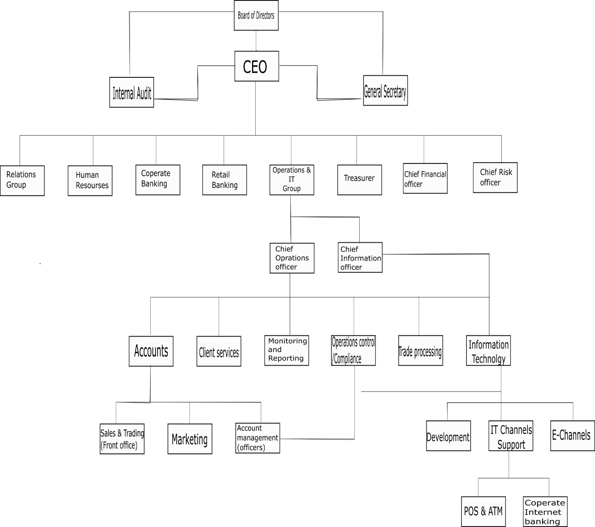

**BOD** – The Board of Directors are at the top of the organization. These include the shareholders founders and co-founders of Globus bank.

**CEO** – The Chief Executive officer of Globus bank, Elias Igbinakenzua.

**CIO** – The Chief Information officer of Globus bank, and head of the IT group, Bola Omole.

**Developers** – This is the group responsible for all the solutions and applications used by Globus bank and its customers.

**E-Channels** – This sub-group is responsible for managing payment channels like USSD, Internet banking etc.

**IT Channels support** – This sub-group is responsible for all activities pertaining to IT payment channel like ATM and POS.

1.3 ROLES/RESPONSIBILITIES AND ACTIVITIES

The *IT channels support* group plays a variety of roles under the Information Technology group. The department of Information Technology, just like every other department of the organization was mandated to resume activities from 8:00am and close by 5:00pm. During the period of this training program, I was assigned to the department of Information Technology - IT channels support.

The IT channels support can be team further divided into smaller units.

* POS/ATM unit
* CIB unit

POS/ATM unit

This is the unit of which I was functioning as an intern. The POS/ATM unit is responsible for the following activities, POS support, ATM support, processing of POS request from Globus bank customers, POS and ATM record management, ATM deployment (in the case of starting up a new branch).

As a support person, I was first assigned to handling incoming POS requests of different merchants. There are a few stages to processing POS requests, but it is important to note the first and last stages: Data capturing and POS deployment. I was assigned to other roles like providing support for POS merchants, ATM monitoring, updating record of (POS) paper-roll requests. Some of these job roles required interaction-skills, critical thinking, attentive listening, while others demanded proficiency in the use of Microsoft office tools. The most important requirement was experience. The more experience you have on the job, the more efficient and effective you become. I believe this concept applies to all job roles.

**CHAPTER TWO**

2.0 DETAILED ROLES/RESPONSIBILITIES AND ACTIVITIES

There are certain activities that are carried out by the IT channel support team. Among these activities, there were few activities I was assigned to take charge of. Some of these activities include.

* Capturing data from Pos request form
* Providing support/Sending support mails
* ATM monitoring
* Updating records

**Capturing data from Pos request forms**: This is the first stage of processing a Pos request form the customers. When a customer decides to become a merchant of Globus bank, a Pos request form is filled. Using the details on the customer’s (Pos request) form, I obtain all necessary information and capture it using an excel sheet. The captured data is the forwarded (to my supervisor) for assignment of parameters like TID, MID and PTSP. This data is then sent to our processors (either Unified payment or Interswitch) for registration. After successful registration, the information is sent to any of our PTSPs for terminal configuration. Finally, the configured Pos terminal is registered on the NIBSS database.

**Providing support/Sending support mails**: Whenever our merchants/customers experience one challenge or another with their terminals it is expected that timely support is provided. Using the concerned merchant’s information from our records, I send support mails to the vendor/PTSP assigned to that terminal to retrieve terminal or resolve the issue. In any situation to which the support mail was not initiated by me, I send subsequent mails to follow up with the vendors on the status of the support.

**ATM monitoring**: as the name implies, this task involves monitoring ATM terminals to ensure an active status. The aim of ATM monitoring is to improve uptime and reduce downtime. The bank’s ATM monitoring solution – Monimanager by Inlaks, made it easy to track the status of all or ATM terminals across the country. I was granted access to this solution, enabling me to keep my supervisor updated on the status of terminals; Inservice, Supervisor mode, out of service. Hence, terminals out of service were addressed physically or virtually (via the Monimanager solution).

**Updating Records**: Some records like *Paper roll request* were updated after any paper roll requests by merchants. I captured most of the data concerning these requests. For example, if a merchant was to request for one carton of Pos paper roll, I would capture the quantity, the date of the request, the status of the request; delivered or pending, and the merchant’s information e.g., TID, merchant name etc. I also updated other records like the *Pos request*, after every new request.

**CHAPTER 3**

3.0 ATM AND POS PAYMENT CHANNELS

The ATM (automated teller machine) is a machine that takes the place of a physical teller and allows the user to carry out multiple transactions e.g., cash withdrawal, fund transfer, balance check and many others.

The Pos (Payment on service) is a device that is also used to carry out transactions, the difference is, it is restricted to making payment, to which these payments are reflected on the account linked to the Pos. This device aids several businesses and depending on how the Pos terminal owner decides to use the terminal, it can be used to carry out other transactions.

Due to the acceptance of debit/credit cards, the ATM and Pos have become very popular physical payment methods in the country.

3.0.1 Terms Associated with ATM

The following are terms associated with Atm, TID, SLA, IP, Port number, Telnet, FEP.

3.0.2 Terms Associated with Pos

The following are terms associated with Pos, TID, SN, MID, PTSP, MCC, Pos request, Support call, Data capturing, Assignment of parameters, Configuration, Registration.

TOOLS AND EQUIPMENTS USED

There are tools and equipment that I used between the period of training program. I made use of a land-line telephone which was provided by the company. I was also provided a PC(Laptop) to have access to some software tools. Some of the software tools I made use of include Microsoft Excel, Microsoft Word, Microsoft Outlook, Monimanager -by Inlaks, NIBSS TLM and MoniPlus -by Inlaks.

Microsoft Word – was used for editing/drafting memos.

3.1 PAYMENT PROCESS – THE BACKEND OF A TRANSACTION

**ATM**

After the user authenticates ownership of card using the pin, and selects a transaction e.g., Cash withdrawal, the bank’s FEP then reads the card information to know the processor to assign the transaction to base on the card type (master card, verve, visa). After the user selects a transaction amount, the processor then checks the account to validate if the available balance supersedes the transaction amount (In the case of a different issuer i.e., a bank card issued by another bank, the switch carries out a validation on the issuers end to validate if available balance is more than the transaction amount.). If this condition is met, the transaction is recorded, and effective changes are made to the available balance on the database. The ATM then grants cash to the user.

**POS**

In a Pos transaction, there are some constants involved in the process.

***The Issuer*** – the bank/financial institution that granted the debit/credit card.

***The Acquirer*** – the bank that owns the Pos terminal i.e., the terminal is registered with NIBSS under that bank’s name.

***The switch*** – enables the Issuer to communicate and make validations with the Acquirer.

After an amount is selected and the user authenticates ownership using the correct pin, the *Acquirer* communicates with the *Issuer* through the *switch* to validate the transaction amount and available balance, if validation is completed, and the conditions are in place, a message “Transaction Approved” is displayed on the terminal.

3.2 POSSIBLE PROBLEMS AND THEIR RESPECTIVE SOLUTIONS

There are some problems that may be encountered during ATM and Pos transactions. During my period of study, I categorized these problems into Server-based problems, Hardware problems, User-based problems, and Network problems.

“Insufficient funds” – User-based problem

“Do not honor” – User-based problem

“Incorrect PIN” - User-based problem

“Issuer or switch inoperative” – Server-based problem

“Intermittent NIBSS downtime” – Server-based problem

“Tampered” -Hardware problem

“Screen fault” – Hardware problem

“exceed withdrawal frequency” – User based problem